Education : Teaching the Basics of KNN, LDA and Simple Perceptron Algorithms for Binary Classification Problems
Sushma.MG(25PG00205)
Chanakya University
Abstract:
One of the main focuses of Education 4.0 is to provide students with knowledge on disruptive technologies, such as Machine Learning (ML), as well as the skills to implement this knowledge to solve real-life problems. Therefore, both students and professors require teaching and learning tools that facilitate the introduction to such topics. Consequently, this study looks forward to contributing to the development of those tools by introducing the basic theory behind three machine learning classifying algorithms: K-Nearest-Neighbor (KNN), Linear Discriminant Analysis and Simple Perceptron; as well as discussing the diverse advantages and disadvantages ofeachmethod. Moreover, it is proposed toanalyze howthesemethodsworkondifferentconditionsthrough their implementation over a test bench. Thus, in addition to the description of each algorithm, we discuss their application to solving three different binary classification problems using three different datasets, as well as comparing their performances in these specific case studies.
Keywords:
educational innovation; higher education; Education 4.0 machine learning; classifying algorithms; KNN; perceptron; test bench

1.Introduction Currently, society is going through the fourth industrial revolution, also known as Industry 4.0. This new revolution is being driven, principally, by advancements in areas such as artificial intelligence (AI), robotics, cloud computing, the internet of things (IoT), cyber-physical systems, big data, etc. [1,2]. Thus, industries have used these technologies to provide solutions to the growing needs of humankind; however, in order for them to continue adapting their ecosystems to the digital world, they need qualified professionals with knowledge and skills in those areas. Consequently, in order to generate skillful personnel, Education 4.0 is being proposed as a new framework so that schools are able to train professionals who are capable of creating knowledge through scientific research and experience, as well as sharing this knowledge with society and using it to face technological, social, political, and economic challenges [3]. Hence, it has been of great importance for universities to develop new cur ricula at the undergraduate level that guide future professionals towards the requirements of Industry 4.0 [4]. Some authors have explored and proposed guidelines for the creation of newly up dated curricula that are in line with the upcoming revolution. According to [3], it is important for Education 4.0 paradigm to be based on competency development so that stu dents do not only memorize and repeat data but also learn how to use it through learning experiences

2.Classification Algorithms Theory
K-Nearest-Neighbors
K-Nearest-Neighbors or KNN is a simple classification algorithm first proposed by Evelyn Fix and Joseph Hodges [32] in 1951 and further developed by Thomas Cover [33] in 1967. This algorithm stores all the input data with its corresponding labels and classifies a newobservation based on similarity [34]. This classification is done based on the labels of its nearest neighbors. The KNN algorithm has been used on several Industry 4.0 frameworkapplications, suchascybersecurity[35], aircraft’s useful life prediction [36], fault classification [37], nephropathy prediction in children [38], intrusion detection systems [39], etc. In order to understand better how KNN works, let us take a brief example. Data about the height and the weight of men and women were gathered and are presented .
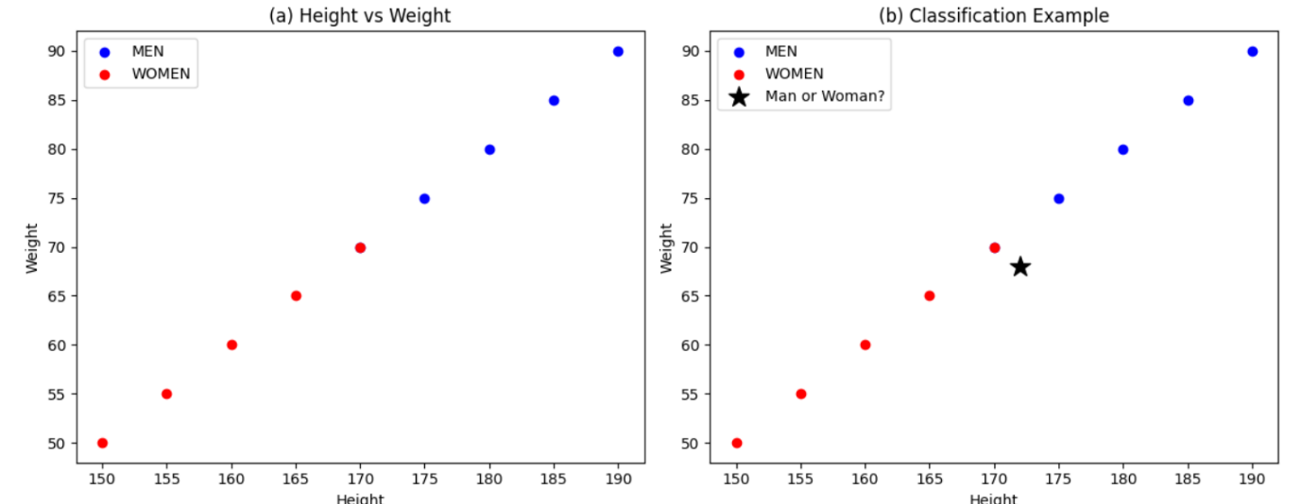
Figure 1a. The blue points represent data that were labeled as men and the red as women. Then, suppose that we add a new individual to the dataset.
We are told that this new individual is a man; however, we only introduce their height and weight to the algorithm to see if it is capable of classifying them correctly. This is shown in To do the classification, we need to search for its nearest neighbors and their cor responding labels so that we can classify this new point depending on the majority of votes from its neighbors. To determine which of the data points are closest to the new observation, we have to measure the distance between data points. There are several types of functions that can be used to obtain the distance between points, such as cosine similarity measure, Minkowsky, correlation, Chi-squared, and Eu clidean distance [40]. From all of these, the most widely used function is the Euclidean distance, which is the measure of the straight line between two points and, for two dimen sions, is obtained as:
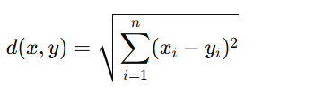
where d represents the distance between two points, and x and y represent the point coordinates. Once we obtain the distance between the new observation and the other points, we can choose the closest neighbors to proceed with the classification. However, an important question arises here: how many nearest neighbors should we consider? Let us take Figure 2 as an example.
In Figure 2, the new observation is being classified by its K nearest neighbors, where K has two different values: K = 3 and K = 7. For K = 3, the closest neighbors are the ones inside the green circle, and for K = 7, the closest neighbors are inside the purple circle. It can be seen that, if K = 3, two of those three neighbors are women, so the new observation would be classified as a woman. However, if K = 7, most of the closest neighbors are men, and then the new individual would be classified as a man. So, for the classification of this newindividual, K = 7 is better than K = 3 because it classified it as a man, which was its real gender. Nevertheless, this does not mean that K = 7 is the best overall value for the dataset; more new observation

Algorithm 1 KNNPseudo-code
Input:
x, l, s // x : training data; l : label; s : sample to classify
for i to training data size do:
Compute the distance d(xi,s)
end for
Select the desired number k of nearest neighbors
Sort the distances by increasing order Count the number of occurrences of each label among the top k neighbors
Output: Assign to s the most frequent label
Linear Discriminant Analysis
Linear Discriminant Analysis or LDA, introduced by Ronald Fisher [41] in 1936, is a linear transformation algorithm used for dimensionality reduction and binary classification. The main objective of this algorithm is to project the data into a lower-dimensional space that maximizes the between-class variance while minimizing the within-class variance [42]. Some of the applications of LDA on Industry 4.0 include state of product detection [43], malfunction monitoring systems [44], EEG hand movement classification [45], etc. That being said, let us explore the theory behind LDA. Let us suppose that we have one independent and one dependent variable, in which the latter is a binary one. The distribution of this variable with respect to the independent variable X1 is as follows: In Figure 3, the blue and purple dots represent the different classes of the dependent variable. As we can see, it is not possible to divide these classes with a linear divider because they are scattered around the X1 axis. Then, we can conclude that a single independent variable is not enough to explain the behavior of our dependent variable. Hence, it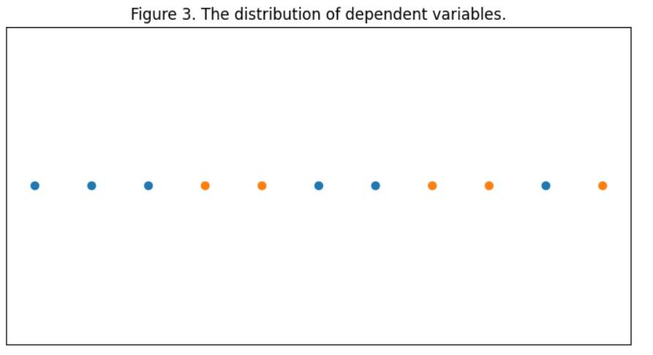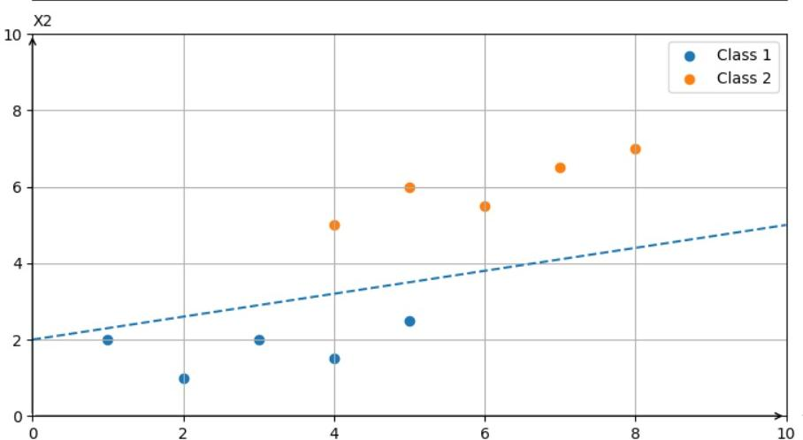
Linear Discriminant Analysis does an analysis over the entire feature space of the problem to create new axes in a lower-dimensional space. In the example we are dealing with, the two feature spaces can be reduced to a 1-D space using LDA to transform the original X1 and X2 axes to a new axis that ensures maximum between-class separability while minimizing within-class variance. It is important to have in mind that both between-class and within-class variance are important for LDA to work correctly. This can be seen in Figures 5 and 6, where Figure 5 only maximizes the between-class variance (arrow between means) while ignoring within class variance (dotted ellipses), which leads to poor separation of classes. On the other hand, Figure 6 shows a new axis that maximizes between-class variance and minimizes within-class variance, leading to good class separation.
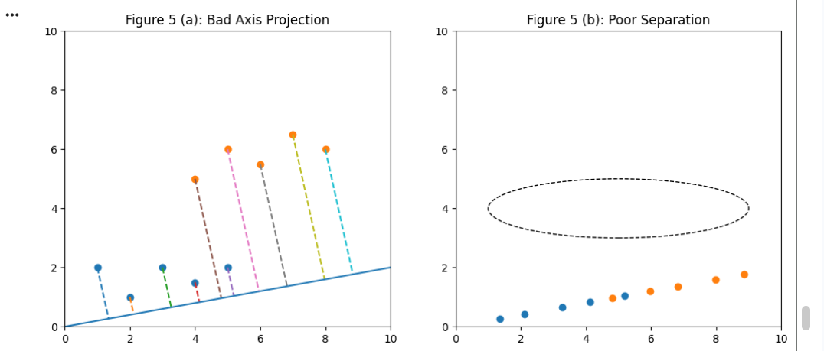

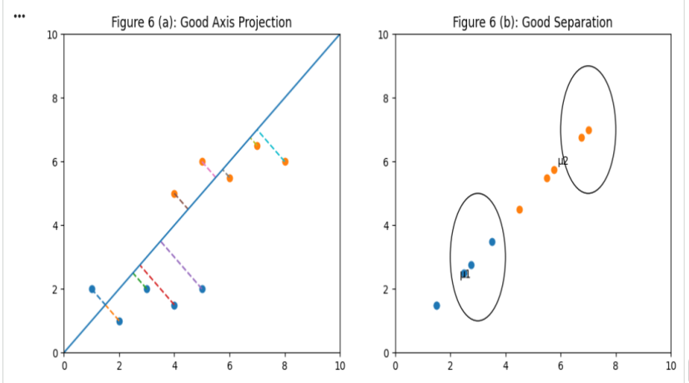
Nowthat wehaveavisual idea of how LDAworks, let us explore the mathematics behind it. The general idea of LDA is to project a high-dimensional space into a line, and this projection must maximize the between-class variance and minimize the within-class variance. To find this projection, the linear discriminant finds a weight vector w that maximizes the Fisher’s criterion, defined as:
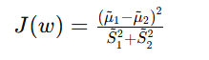
Simple Perceptron
The perceptron, first introduced by Rosenblatt [46], is the fundamental unit of artificial neural networks, just as the neuron is the fundamental unit of our central nervous system. Hence, it conforms the basis of advanced ML methods that are used on several real-life applications on Industry 4.0, such as smart manufacturing [47], condition monitoring [48], material selection [49], building occupancy prediction [50], among others. In the basic applications of Machine Learning, the Simple Perceptron is used as a supervised binary classifier [51], and it has four parts
1. Input
2. Weight and bias
3. Net sum
4.Activation function
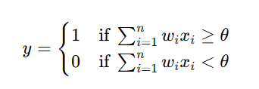
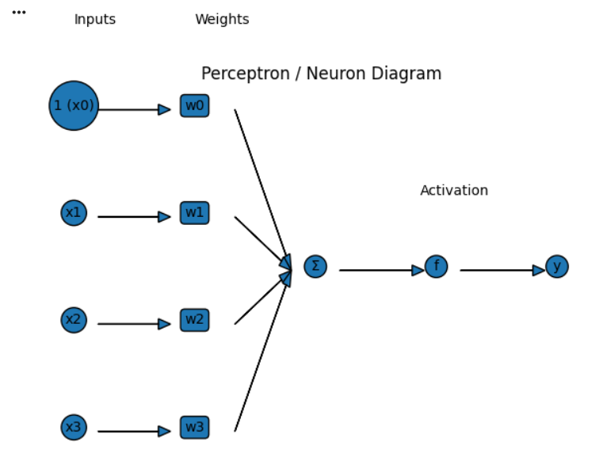
- Case Studies
As mentioned earlier, one of the main pillars of Education 4.0 is not only to teach students the theory behind disruptive technologies, such as ML, but also to provide the learning material so that they can have the opportunity of applying the acquired knowledge to develop problem-solving skills, as well competencies such as design mindset, transdisciplinary approach and computational skills [3]. Thus, the previous ML algorithms were applied over three different datasets while showing and analyzing the results so that they can be employed by students to learn more about their application. Moreover, providing this test bench is not only useful for students but also for teachers as support material on Machine Learning lessons. For example, it can be used as a project in which students must replicate the results presented here so that they can develop computational skills over ML problems. Furthermore, teachers can entrust students to design their own experiment so that they apply the methods on a different dataset of their choice to see how it works, compare the obtained performance, and analyze why they were good or bad classifiers for the proposed new dataset.

2. Method
To estimate the performance of KNN, LDA, and Perceptron, we used repeated k fold cross-validation, with k = 5 and 100 repetitions for each algorithm. For the KNN algorithm, a number of 23 close neighbors was found to be the best choice for the Cleveland dataset, while for Banknote and Wisconsin datasets, 4 and 5 close neighbors were the best choices, respectively.
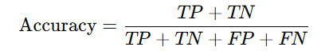
Results
Foreachofthepreviousmetrics,KNN,LDA,andSimplePerceptronobtainedthe meanvaluesshowninTables2–4.Analyzingthem,wecanobservethatfortheCleveland dataset,theKNNalgorithmshowedthebestbehaviorforAUC,FPR,TNR,andPPV;for theothermetrics,thebestalgorithmwasLDA.FortheBanknotedataset,KNNwasthebest classifierforalmostallthemetrics,exceptAUC,whereLDAhadthebestresult.Finally,for theWisconsindataset,PerceptronoutperformedtheothertwoalgorithmsonACC,TPR, FNR,andNPV,whileLDAhadthebestperformanceforAUCandKNNforFPR,TNR, andPPV
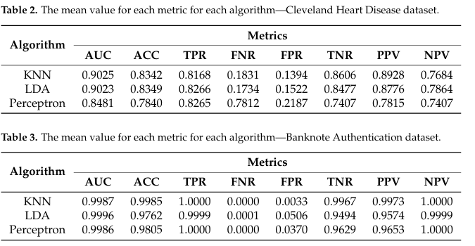
Referances
1.Xu, L.D.; Xu, E.L.; Li, L. Industry 4.0: State of the art and future trends. Int. J. Prod. Res. 2018, 56, 2941–2962. [CrossRef]
2.Rodríguez-Abitia, G.; Bribiesca-Correa, G. Assessing Digital Transformation in Universities. Future Internet 2021, 13, 52. [CrossRef]
3.Ramirez-Mendoza, R.A.; Morales-Menendez, R.; Iqbal, H.; Parra-Saldivar, R. Engineering Education 4.0: Proposal for a new Curricula. In Proceedings of the 2018 IEEE Global Engineering Education Conference (EDUCON), Santa Cruz de Tenerife, Spain, 17–20 April 2018; pp. 1273–1282.
4.Karacay, G. Talent development for Industry 4.0. In Industry 4.0: Managing the Digital Transformation; Springer: Berlin/Heidelberg, Germany, 2018; pp. 123–136.
5.Quintana, C.D.D.; Mora, J.G.; Pérez, P.J.; Vila, L.E. Enhancing the development of competencies: The role of UBC. Eur. J. Educ. 2016, 51, 10–24. [CrossRef]
6.Prieto, M.D.; Sobrino, Á.F.; Soto, L.R.; Romero, D.; Biosca, P.F.; Martínez, L.R. Active learning based laboratory towards engineering education 4.0. In Proceedings of the 2019 24th IEEE International Conference on Emerging Technologies and Factory Automation (ETFA), Zaragoza, Spain, 10–13 September 2019; pp. 776–783.
7.Zhang, X.D. A Matrix Algebra Approach to Artificial Intelligence; Springer: Berlin/Heidelberg, Germany, 2020.
8.Ahmad,M.A.;Eckert, C.; Teredesai, A. Interpretable machine learning in healthcare. In Proceedings of the 2018 ACMInternational Conference on Bioinformatics, Computational 9.Biology, and Health Informatics, Washington, DC, USA, 29 August–1 September 2018; pp. 559–560.
10.Parthiban, G.; Srivatsa, S. Applying machine learning methods in diagnosing heart disease for diabetic patients. Int. J. Appl. Inf. Syst. (IJAIS) 2012, 3, 25–30. [CrossRef]

